Paper Title - Arial 14pt Bold (Title style)
Author Name
Job title, Organisation, Organisation Address,
Email

Page length 6-10 pages

Abstract - (Heading 1 style)

Text – Arial 11 pt, normal text (Normal style).
Please include an abstract not exceeding 250 words

Key Words:

Heading Level 1 – Arial 12pt, Bold, Numbering (Heading 1 style)

Text – Arial 11 pt, normal text (Normal style).
The conference was successfully organised and the delegates were very satisfied with the event. In the feedback survey, there were some weaknesses identified which we will address in the future conferences. From the next conference, we will take care when selecting papers/presentations to cover different areas. About the guest, the executive committee will decide the best way forward. With these commitments, we hope that many more of you will be attending the next conference. See you then!

Heading Level 2 – Arial 11pt, Bold, Numbering (Heading 2 style)
Text – Arial 11 pt, normal text (Normal style).
The conference was successfully organised and the delegates were very satisfied with the event. In the feedback survey, there were some weaknesses identified which we will address in the future conferences. From the next conference, we will take care when selecting papers/presentations to cover different areas. About the guest, the executive committee will decide the best way forward. With these commitments, we hope that many more of you will be attending the next conference. See you then!

Table format: Centred, Table caption above Table, Arial 11 pt, numbered.

Table 1: Mechanisms to transfer knowledge and technology to Nepal
Themes | Mechanisms
Health and Safety | Establish permanent body/committee for SONE UK representing various disciplines (Scope of work, TOR)
Policy formulation and development | Permanent contact and regular communication to work with
Expert services | E-library (this explained in section 4 serves both for SONE-UK members as well as for the relevant people from Nepal)

Figure format: Centred, Figure caption below Figure, Arial 11 pt, numbered.

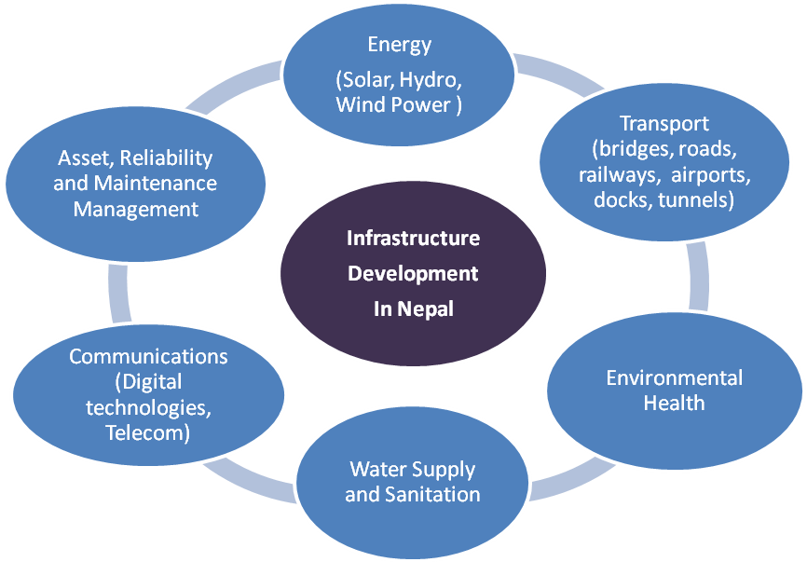
Figure 1: Facets of Infrastructure Development and Engineering Disciplines

Results
The conference was successfully organised and the delegates were very satisfied with the event. In the feedback survey, there were some weaknesses identified which we will address in the future conferences. From the next conference, we will take care when selecting papers/presentations to cover different areas. About the guest, the executive committee will decide the best way forward. With these commitments, we hope that many more of you will be attending the next conference. See you then!

Base case
The conference was successfully organised and the delegates were very satisfied with the event.

Do-something case
The conference was successfully organised and the delegates were very satisfied with the event.

References
UNESCO (2010). Engineering: issues, challenges and opportunities for development. [online], http://unesdoc.unesco.org/images/0018/001897/189753e.pdf accessed online 10/02/2017.

Please use Harvard Referencing system

